2025 Nurse Advice Line Fall Update
When: 9/23/2025 8:00 AM - 1:30 PM | Activity ID: 8471
Location: TEAMS
Agenda:
0800-0900
Operation Breakthrough
Gladesia Tolbert, DNP, APRN
0900-1000
Pediatric Dental Issues
Robin Onikul, DDS
Gladis Washington,
Dental Hygienist/Clinic Manager

1000-1010 Break
10:15-11:15
Common Sleep Concerns
Shauna Vandoren, DO
Sleep Medicine

11:15-12:15
Recognizing Red Flags of Potential Child Abuse
Daniella Donofrio, LCSW, LMSW
Lisa Post-Jones, MSN, RN, CPN, SANE-P
Shelley Serrano, MSN, RN, CPN
SCAN Clinic

12:30-1:30
CM Values and DiSC
Tony Thompson, MA
Berry Institute

ACCREDITATION:

Participants who complete the requirements for successful completion will receive 5 nursing contact hours.
Requirements for successful completion
Attend the entire activity
Complete the evaluation.



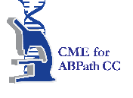

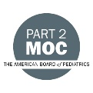

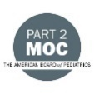



Nursing Contact Hours
This educational activity has been awarded 5.00 nursing contact hours.
Children's Mercy Kansas City is approved as a provider of nursing continuing professional development by the Midwest Multistate Division, an accredited provider by the American Nurses Credntialing Center's Commission on Accreditation.

